41.51: a) To calculate the total number of states for the 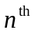 principle quantum number shell we must multiply all the possibilities. The spin states multiply everything by 2. The maximum l value is (n –1), and each l value has 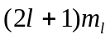 values.
So the total number of states is
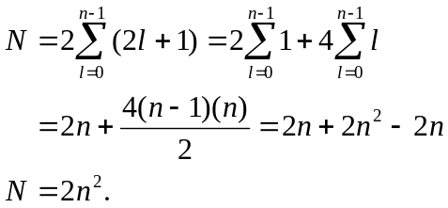
b) The n = 5 shell (O-shell) has 50 states.

